**HTML <sub> Tag**

Last Updated : 21 Aug, 2024

The**<sub> tag in HTML** is used to define subscript text, which appears smaller and slightly below the normal text baseline. It is commonly used for mathematical expressions, chemical formulas, and footnotes, like in H₂O (water) or E=mc² (Einstein’s equation).

**Syntax**

<sub> Contents. . . </sub>

There are no such attributes that apply specifically to this <sub> tag. The attributes that only apply to this tag are global attributes.

**Example 1:** In this example, the <sub> tag is used to create subscript text. The “2” in the chemical formula “H₂O” is displayed as smaller and slightly lower than the baseline, indicating the number of hydrogen atoms.



1

<!DOCTYPE html>

2

<html>

3

​

4

<head>

5

<title>HTML sub tag</title>

6

</head>

7

​

8

<body style="text-align: center;">

9

​

10

<h1 style="color: green;">

11

GeeksforGeeks

12

</h1>

13

​

14

<h2>Chemical Formula of Water</h2>

15

​

16

<h2>H<sub>2</sub>O</h2>

17

</body>

18

​

19

</html>

**Output:**

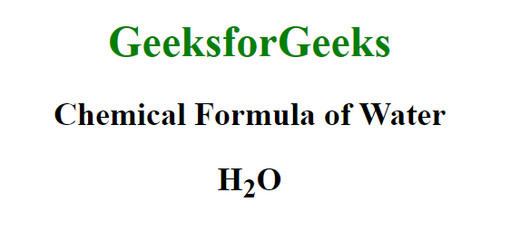

**Example 2:**In this example the <sub> tag is used to display subscript text. It renders the “n” in the mathematical expression “xₙ + yₙ” smaller and below the baseline, indicating a variable’s subscript.



1

<!DOCTYPE html>

2

<html>

3

​

4

<head>

5

<table>

6

HTML sub tag

7

</table>

8

</head>

9

​

10

<body style="text-align: center;">

11

​

12

<h1 style="color: green;">

13

GeeksforGeeks

14

</h1>

15

​

16

<h2>Mathematical Formula</h2>

17

​

18

<h2>x<sub>n</sub> + y<sub>n</sub></h2>

19

</body>

20

​

21

</html>

**Output:**

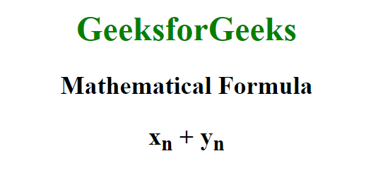

**Supported Browsers:**

* [Google Chrome](https://www.geeksforgeeks.org/google-chrome-browser)
* [Edge](https://www.geeksforgeeks.org/microsoft-edge-browser)
* [Firefox](https://www.geeksforgeeks.org/mozilla-firefox-browser)
* [Opera](https://www.geeksforgeeks.org/opera-browser)
* [Safari](https://www.geeksforgeeks.org/apple-safari-browser)

**HTML <sub> tag-FAQs**

**What is the difference between <sub> and <sup> tags in HTML?**

*The <sub> tag is for subscript text (below the baseline), while the <sup> tag is for superscript text (above the baseline).*

**Is the <sub> tag a block or inline element?**

*The <sub> tag is an inline element, meaning it does not cause line breaks and is used within sentences or headings.*

**What are the global attributes that can be used with the <sub> tag?**

*The <sub> tag supp*